Gradle
# Source: AI Source: Provided by: [Data Path: Persons Table -> ID Column: 1, Name_En Column: Motasem Essam] -> From: [ChatGPT] on [1/26/2026]
Gradle is a modern build automation and dependency management tool, primarily for Java, Kotlin, and Android projects.
It is similar in purpose to Maven, but offers more flexibility and faster builds.

Key Features of Gradle
# Source: AI Source: Provided by: [Data Path: Persons Table -> ID Column: 1, Name_En Column: Motasem Essam] -> From: [ChatGPT] on [1/26/2026]
- Dependency Management
  - Automatically downloads libraries (dependencies) your project needs.
  - Supports Maven and Ivy repositories.
- Build Automation
  - Compiles code, runs tests, packages artifacts (JAR, WAR, APK), and deploys.
- Highly Configurable
  - Uses a DSL (Domain-Specific Language) in Groovy or Kotlin to define build scripts (build.gradle or build.gradle.kts).
  - More flexible than Maven’s XML approach.
- Incremental Builds
  - Only rebuilds parts of the project that changed, making builds faster.

what is build.gradle
# Source: AI Source: Provided by: [Data Path: Persons Table -> ID Column: 1, Name_En Column: Motasem Essam] -> From: [ChatGPT] on [1/26/2026]
build.gradle is the main build script file used by Gradle, a popular build automation tool for Java, Kotlin, Android, and other JVM projects.
It defines how your project should be built, tested, and packaged, as well as its dependencies.

1️⃣ Location
# Source: AI Source: Provided by: [Data Path: Persons Table -> ID Column: 1, Name_En Column: Motasem Essam] -> From: [ChatGPT] on [1/26/2026]
- Typically in the root folder of a project:
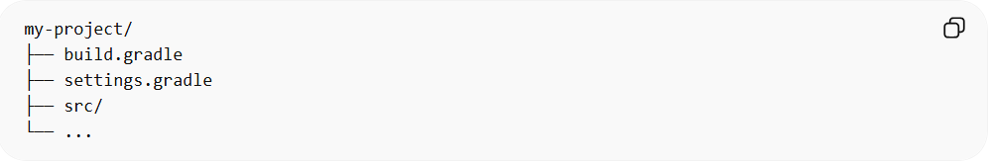
my-project/
├── build.gradle
├── settings.gradle
├── src/
└── ...

2️⃣ Purpose
# Source: AI Source: Provided by: [Data Path: Persons Table -> ID Column: 1, Name_En Column: Motasem Essam] -> From: [ChatGPT] on [1/26/2026]
- Declare dependencies your project needs
- Define tasks for compiling, testing, and packaging
- Configure plugins (like Java plugin, Kotlin plugin, or Android plugin)
- Automate repetitive tasks

3️⃣ Example build.gradle (Groovy DSL)
# Source: AI Source: Provided by: [Data Path: Persons Table -> ID Column: 1, Name_En Column: Motasem Essam] -> From: [ChatGPT] on [1/26/2026]
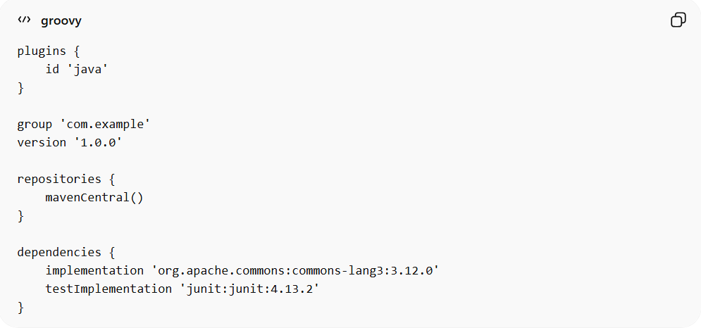
plugins {
id 'java'
}

group 'com.example'
version '1.0.0'

repositories {
mavenCentral()
}

dependencies {
implementation 'org.apache.commons:commons-lang3:3.12.0'
testImplementation 'junit:junit:4.13.2'
}
Explanation:
- plugins { id 'java' } → Applies the Java plugin to compile and build Java code
- group & version → Project coordinates (like Maven GAV)
- repositories → Where to download dependencies (Maven Central in this case)
- dependencies → Libraries required:
  - implementation → Needed for building/running the app
  - testImplementation → Needed only for testing

4️⃣ Common Gradle Commands with build.gradle
# Source: AI Source: Provided by: [Data Path: Persons Table -> ID Column: 1, Name_En Column: Motasem Essam] -> From: [ChatGPT] on [1/26/2026]
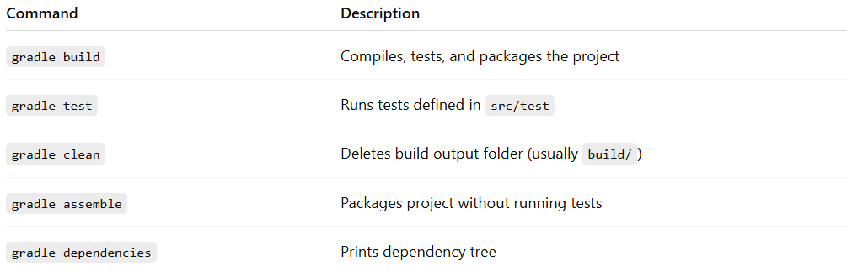
Command | Description
gradle build | Compiles, tests, and packages the project
gradle test | Runs tests defined in src/test
gradle clean | Deletes build output folder (usually build/)
gradle assemble | Packages project without running tests
gradle dependencies | Prints dependency tree

✅ Summary
- build.gradle = blueprint of your project for Gradle
- Defines dependencies, plugins, tasks, and project metadata
- Essential for automating builds and managing dependencies

Common Gradle Commands
# Source: AI Source: Provided by: [Data Path: Persons Table -> ID Column: 1, Name_En Column: Motasem Essam] -> From: [ChatGPT] on [1/26/2026]
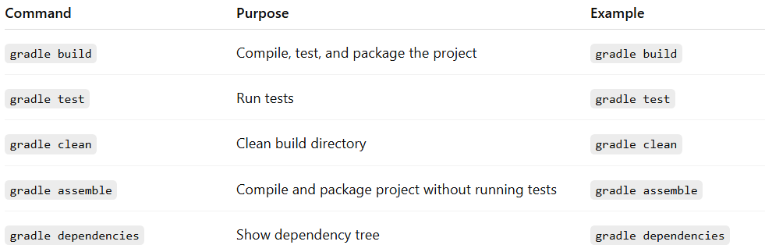
Command | Purpose | Example
gradle build | Compile, test, and package the project | gradle build
gradle test | Run tests | gradle test
gradle clean | Clean build directory | gradle clean
gradle assemble | Compile and package project without running tests | gradle assemble
gradle dependencies | Show dependency tree | gradle dependencies

✅ Summary
# Source: AI Source: Provided by: [Data Path: Persons Table -> ID Column: 1, Name_En Column: Motasem Essam] -> From: [ChatGPT] on [1/26/2026]
- Gradle = build automation + dependency manager for Java/Kotlin/Android
- Uses Groovy or Kotlin DSL for flexible build scripts
- Supports fast incremental builds and complex workflows
- Can replace or complement Maven

